



**Revision History**

| **Date** | **Version** | **Author** | **Change Description** |
| --- | --- | --- | --- |
| 09/06/2021 | 0.1 | Your name | Initial creation |
|  |  |  |  |
|  |  |  |  |
|  |  |  |  |
|  |  |  |  |

**Approval**

| **Date** | **Version** | **Approver Name** | **Position** |
| --- | --- | --- | --- |
|  | 0.1 | Peter Tran | Application Owner |
|  | 0.1 | Thomas Yoshida | ITPM |
|  |  |  |  |
|  |  |  |  |
|  |  |  |  |
|  |  |  |  |

**Table of Contents**

1 Objective and Scope 3

2 Business Requirement 3

2.1. Application Overview 3

2.2. Domain Model 4

2.2.1. Diagram 4

2.2.2. Domain Objects Description 5

2.3. Workflow 6

2.4. Use Cases and Actors 8

2.4.1. Diagram 8

2.4.2. Description of Actors 8

2.4.3. Description of Use Cases 9

2.5. Security Matrix 9

2.6. Change Requirement 10

3 Appendix 11

3.1. Glossary 11

3.2. Open Issues 11

# Objective and Scope

This document describes the business requirements for T&L Project. It contains the overall description of the application, the scope of data migration, and any changes need to be performed during migration the application.

This document along with the prototype demo is used for requirements confirmation, and it is to be signed off by the business. Details of business logic and graphic user interface of the application, which are not mentioned in this document, will be migrated as they are in the the application.

# Business Requirement

# Application Overview

# Domain Model

# Diagram

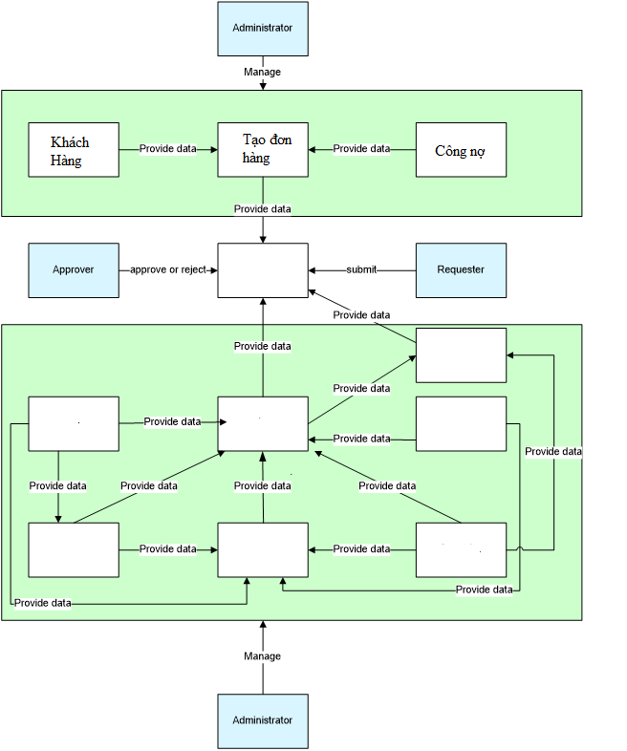

# Domain Objects Description

| # | Object Name | Object Description |
| --- | --- | --- |
| 1 | Khách hàng | Mô tả đối tượng khách hàng ở đây |
| 2 |  |  |
| 3 |  |  |
| 4 |  |  |
| 5 |  |  |
| 6 |  |  |
| 7 |  |  |
| 8 |  |  |
| 9 |  |  |
| 10 |  |  |
| 11 |  |  |
| 12 |  |  |

# Workflow

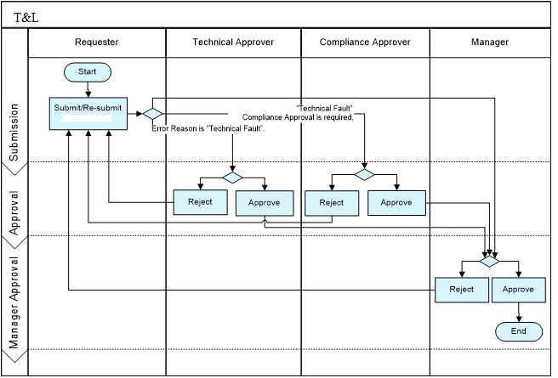

State Transition Diagram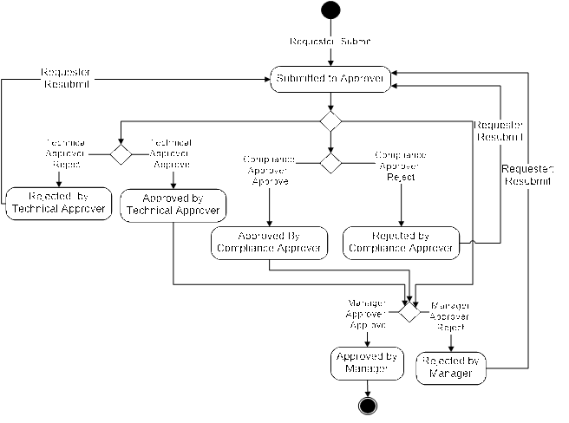

# Use Cases and Actors

# Diagram

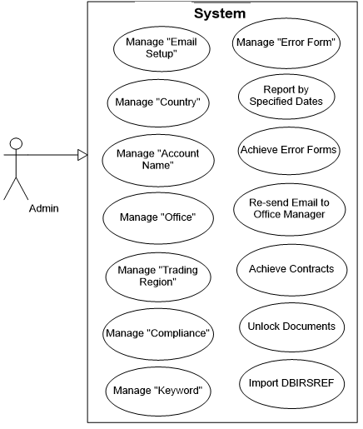

# Description of Actors

| # | Actor Name | Definition |
| --- | --- | --- |
| 1 | Admin |  |
| 2 |  |  |
| 3 |  |  |
| 4 |  |  |
| 5 |  |  |
| 6 |  |  |

# Description of Use Cases

| # | Use Case Name | Definition |
| --- | --- | --- |
| 1 | Manage “Email Setup” | Manage all information of “Email Setup” |
| 2 | Manage “Product” | Manage all information of “Product” |
| 3 | Manage “Keyword” | Manage all information of “Keyword” |
| 4 | Send To Next Approver | This use case allows requesters to send the error form to the approver |
| 5 | Approve Error Form | This use case allows approvers to approve the error form |
| 6 | Reject Error Form | This use case allows approvers to reject the error form |
| 7 | Resubmit Document | This use case allows users to make the document as if it is a new document and restart the workflow |
| 8 | Archive Contracts | This use case allows users to update all selected “Contract” items to archive status. |
| 9 | Unlock Document | This use case allows users to reset access permission of sections in an “Error Form” item. |
| 10 | Report by Specified Date | This use case allows users to Report by Specified Date of selected “Error Form” items. |
| 11 | Archive Error Forms | This use case allows users to update all selected “Error Form” items to archive status |
| 12 | Re-Send E-Mail to Office Manager | This use case allows users to resend e-mail to office manager. |
| 13 | Update Security | This use case allows users to update security. |
| 14 | Update Euro Values | This use case allows users to update Euro Values. |
| 15 | Import DBIRSREF | This use case allows users to import DBIRSREF. |
| 16 |  |  |
| 17 |  |  |
| 18 |  |  |
| 19 |  |  |

# Security Matrix

| Actor  Function | Tác nhân 1 | Tác nhân 2 | Tác nhân 3 | Tác nhân 4 | Tác nhân 5 | Tác nhân 6 |
| --- | --- | --- | --- | --- | --- | --- |
| **Chức năng 1** |  |  |  |  |  |  |
| Chức năng 1.1 | x(*) | x |  |  |  |  |
| Chức năng 1.2 | x(*) |  |  |  |  |  |
| Chức năng 1.3 |  | x |  |  |  |  |
| Chức năng 1.4 | x(*) | x | x(**) | x | x |  |
| **Chức năng 2** |  |  |  |  |  |  |
|  |  |  |  |  |  |  |
|  |  |  |  |  |  |  |
|  |  |  |  |  |  |  |
|  |  |  |  |  |  |  |

# Change Requirement

| # | Item Name | Change Description |
| --- | --- | --- |
| 1 |  |  |
| 2 |  |  |
| 3 |  |  |
| 4 |  |  |
| 5 |  |  |
| 6 |  |  |
| 7 |  |  |

# Appendix

# Glossary

| Term | Description |
| --- | --- |
| BRD | Business Requirements Document |
| DB | T&L Database |
|  |  |

# Open Issues